See Screening Sheet on page D-59 of Pub 4012 to determine if COD is in scope.

Taxpayer receives a 1099-C from a credit card company or bank. The amount of the debt canceled is shown in Box 2 of 1099C.
- Canceled debt is generally considered income and is reported on the 1040, Schedule 1 line 8, other income, UNLESS the taxpayer was in bankruptcy or insolvent (i.e., the taxpayer’s liabilities exceeded assets) immediately before the debt was canceled.
- If the taxpayer was in bankruptcy or insolvent immediately before the debt was canceled, all or part of the canceled debt may be excludable from income.
  - Cases involving bankruptcy or insolvency are OUT OF SCOPE...
- The preparer needs to ask taxpayer if they were in bankruptcy or might have been insolvent immediately before the debt was canceled; if “yes” or “not sure,” we must refer the client to a paid preparer. (OUT OF SCOPE)
- The debt must be personal (i.e. NOT related to a business)
  - Cases involving business related debt are OUT OF SCOPE...
- Credit card cancellation of debt is reported on a 1099-C if the amount is over $600. Any amounts less than $600 not reported on a 1099-C are still taxable.
- The amount of interest shown in box 3 can be ignored since it is included in box 2 and is taxable.
- All other types of forgiven debt including Qualified Principal Residence Indebtedness is OUT OF SCOPE.
- Cancellation of debt amounts are not taxable in NJ.
Example
Fred runs up $15,000 in credit card debt and can’t pay. He works out a deal with the credit card company to settle for $10,000 and the rest of the debt is canceled. Fred was solvent immediately before the debt was canceled. Fred receives a 1099-C from the creditor shown below: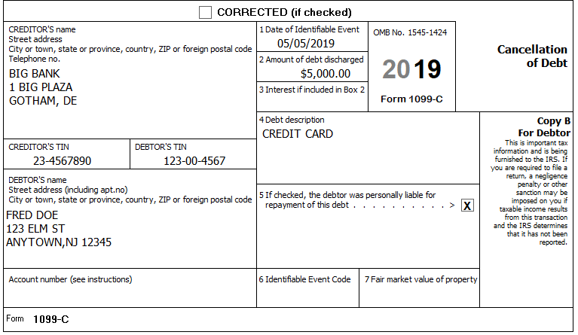
The consequence is $5,000 of taxable income which is reported on the 1040, Schedule 1, line 8, other income, as CANCELLED DEBT.

Step 1: In TSO, enter 1099-C in the search box.
Step 2: Go to 4012 Pages D-60 and follow the screen entries on this page
Step 3: The amount entered on 1040, Schedule 1, line 8 of the Federal return should not go to line 26 (Other Income) of the NJ return. TSO seems to be doing this correctly. Check the NJ return to be sure.

